Multi-Cycle

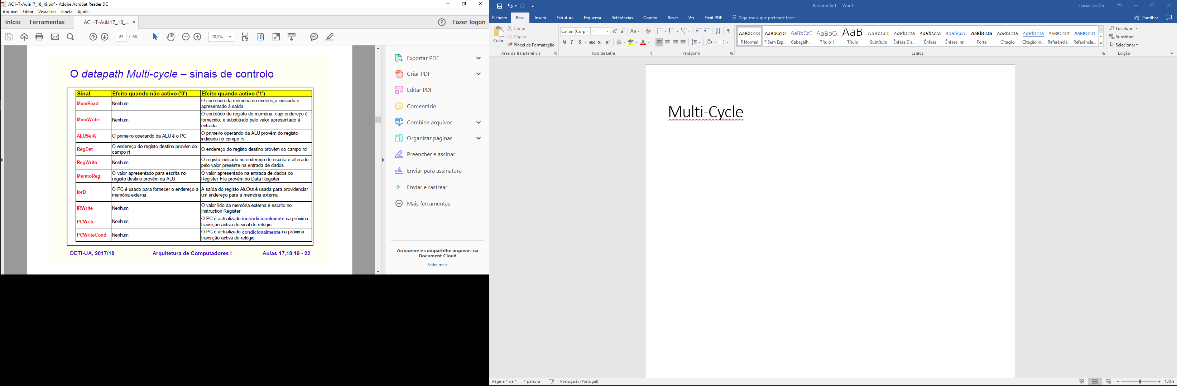

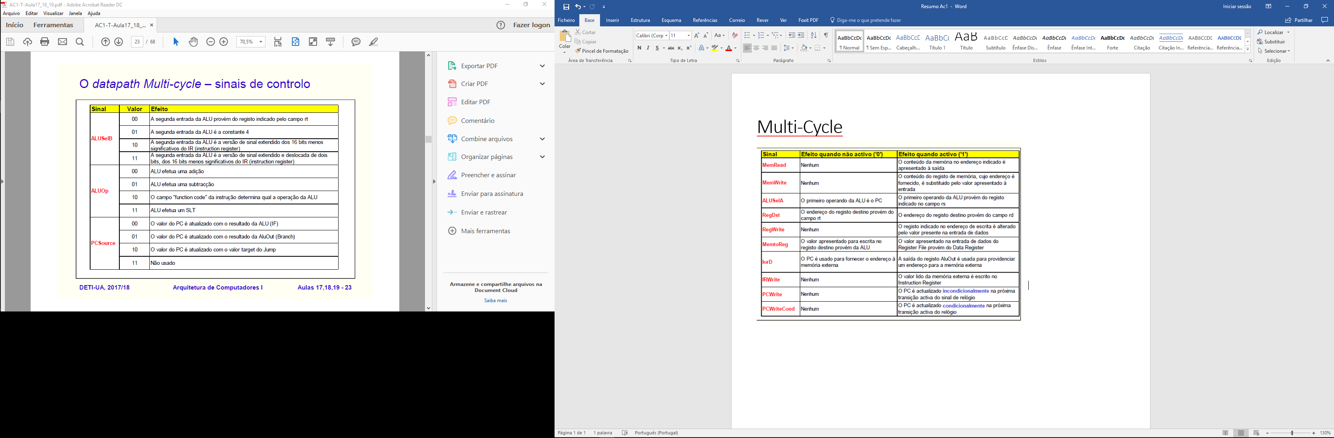

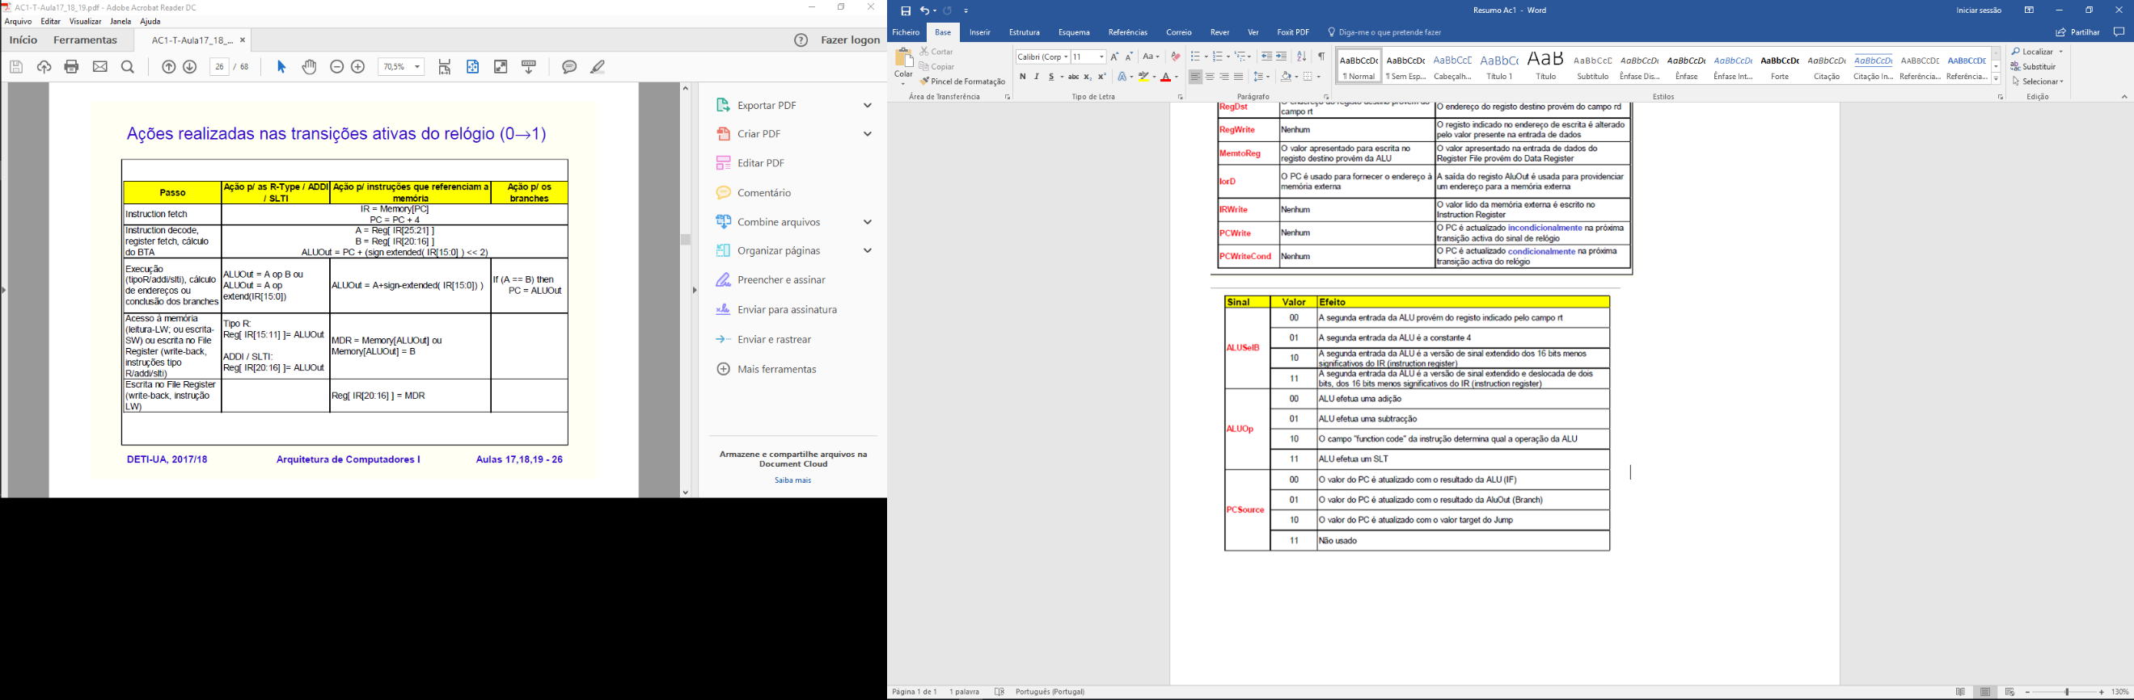

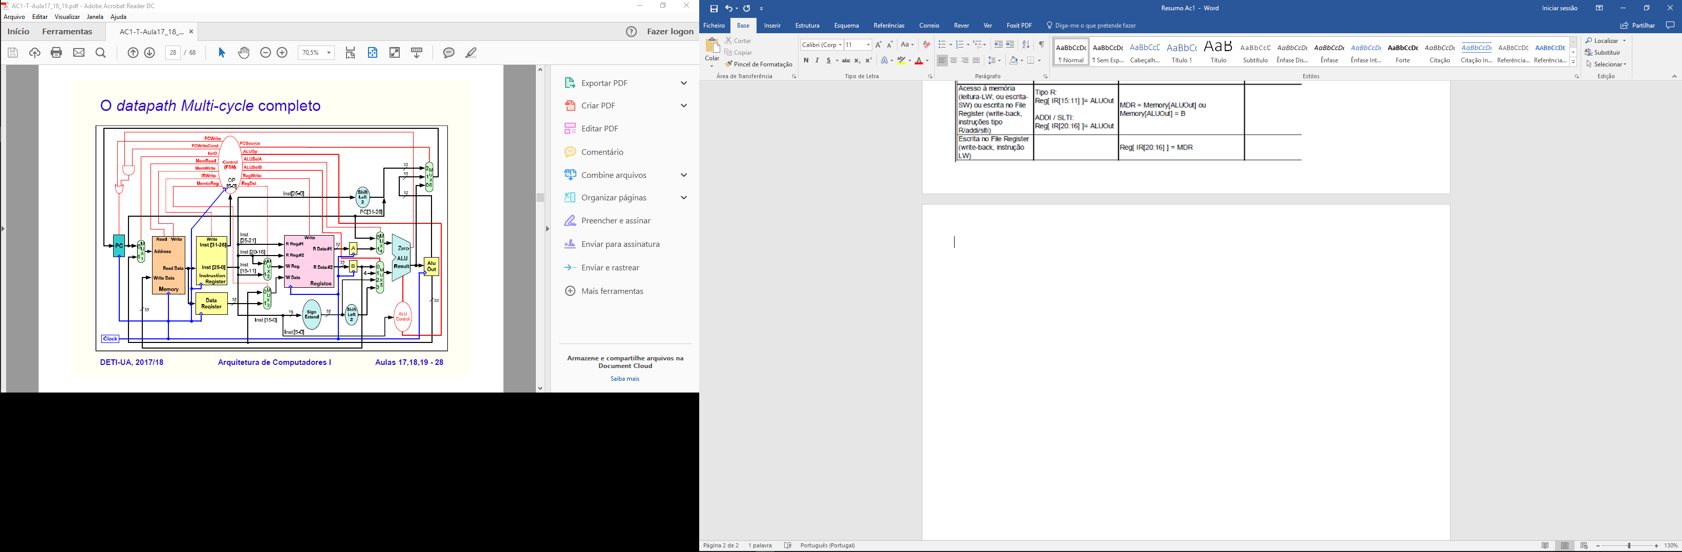

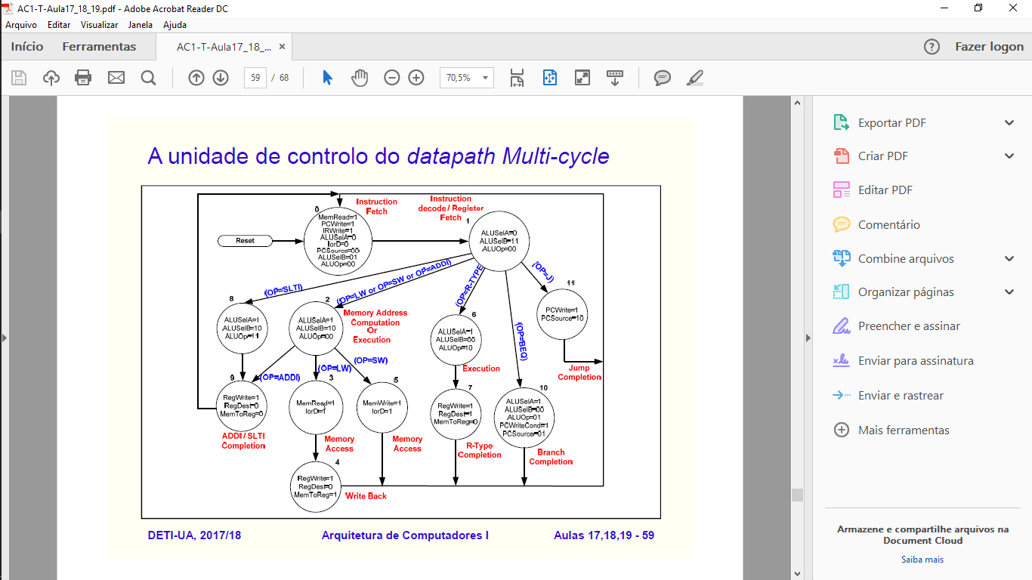

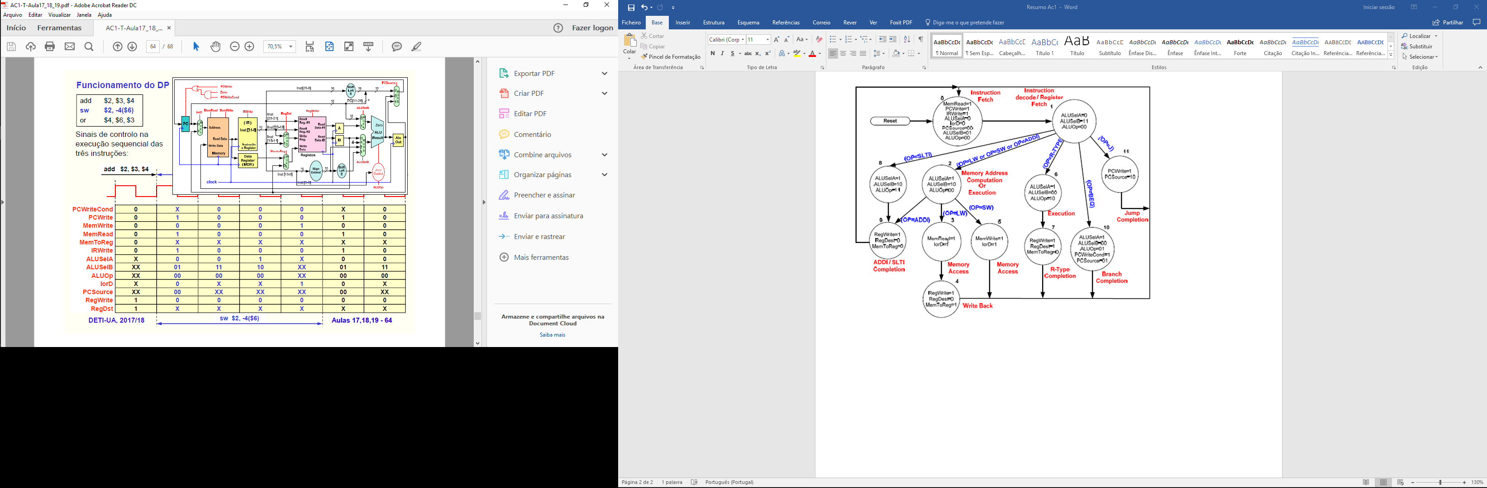

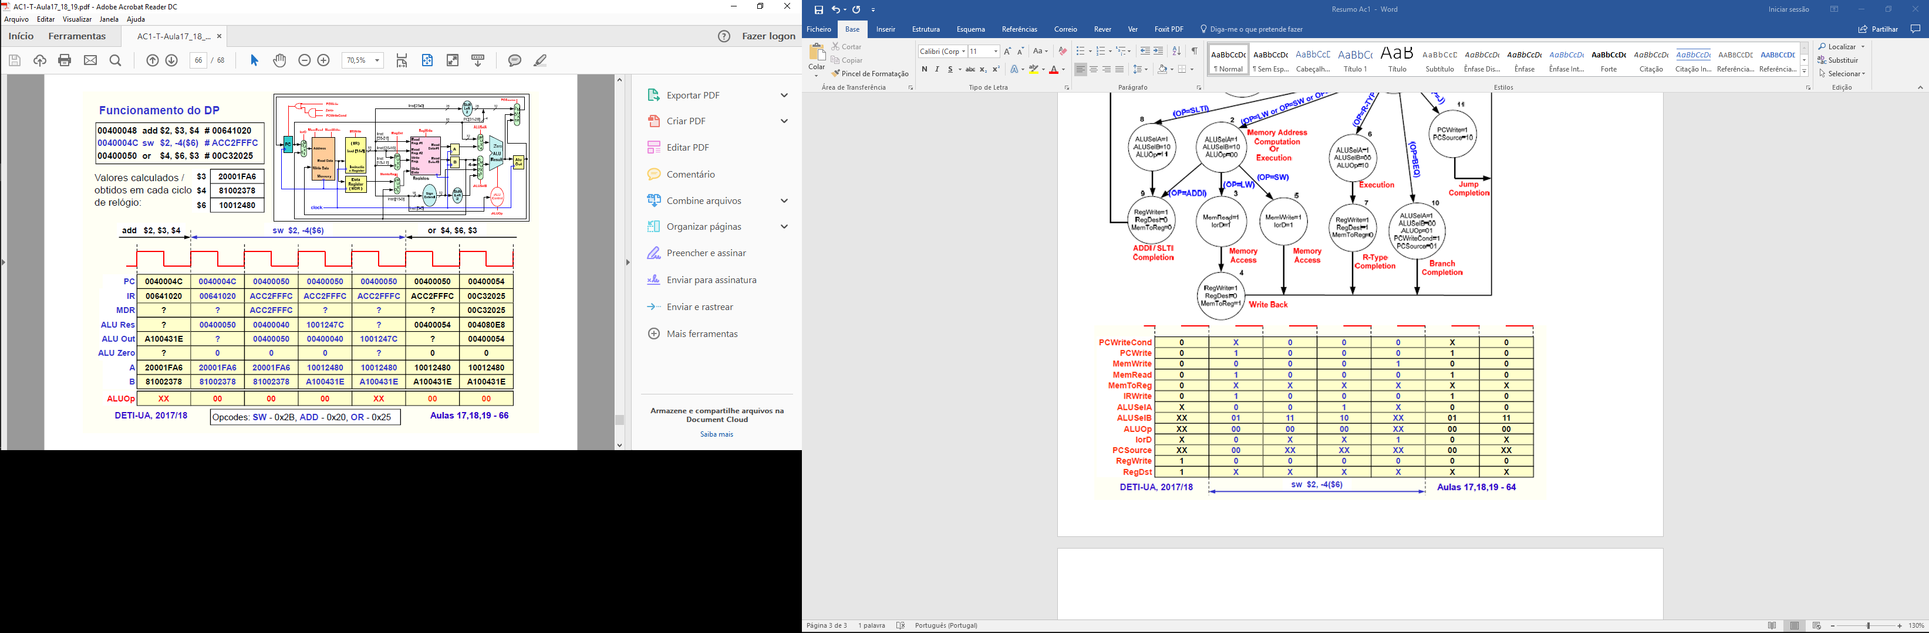

Pipeline

